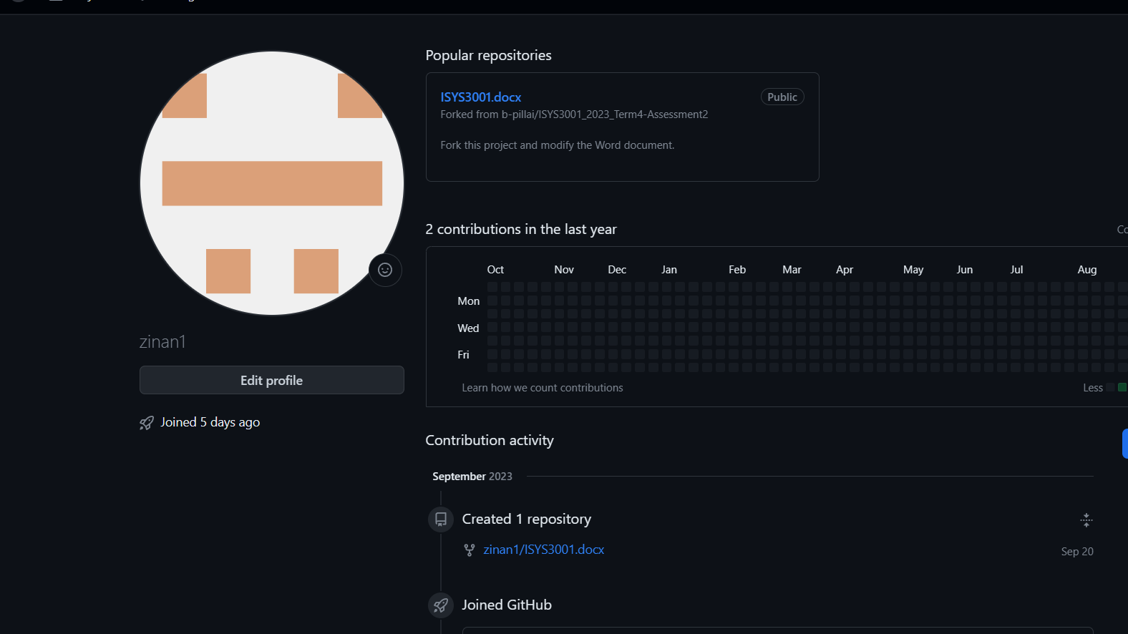

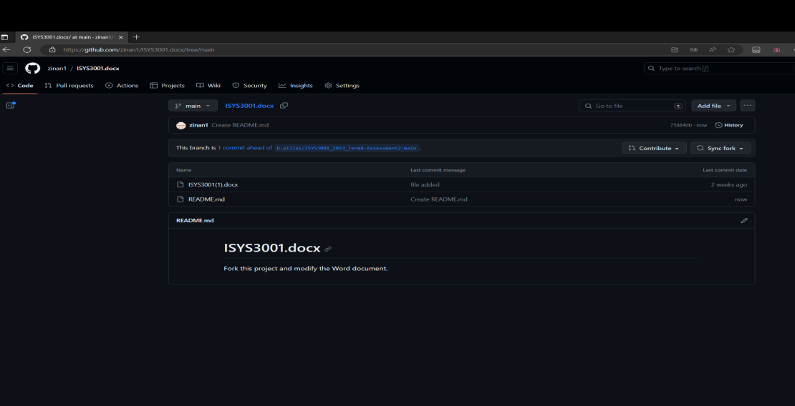

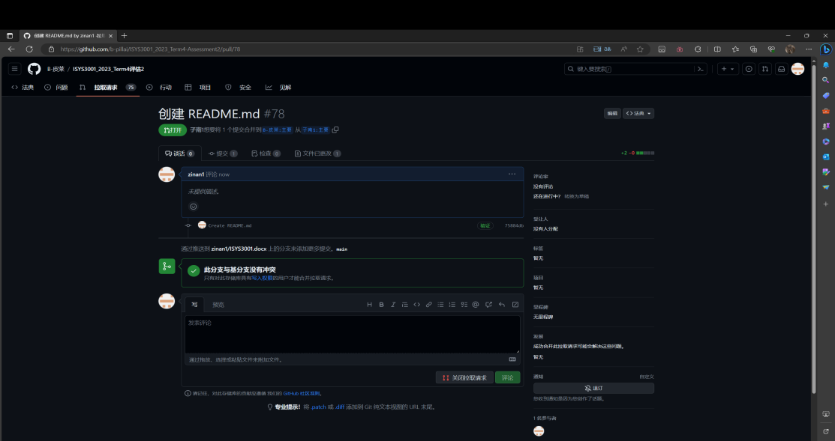

**Configuration Management**

**Change management:** Strengthen the process of change management, such as formalizing the approval of all changes, encouraging cooperation and communication among departments to ensure the participation of all stakeholders in the change process.

**Version management:** Establish a version control system, such as Git, to effectively track and manage code changes, facilitate developers to call and debug each version, and clearly demonstrate the compatibility and variability between versions to ensure development consistency.

**System building:** Adopting a continuous integration and automated construction process to facilitate the interaction between modifications by different developers, problems can be detected early and will not compound.When continuous integration is not possible, adopt a daily generation process to reduce the complexity of system construction.During the construction process, it is also necessary to consider three elements: developer platform, construction platform, and target platform

**Release management:** Establish a standardized and strict release process, conduct thorough testing and verification before the product is launched, ensure the stability and reliability of the software, establish appropriate feedback mechanisms, and facilitate the collection of issues that users encounter during use.

**Request For Proposal**

**Table Of Contents**

1. **About As**
2. **System And Requirements Description**
3. **Evaluate Proposal**
4. **Time Frame And Budget**
5. **Contact Us**
6. **About As**

Aussie Business Buzz (ABB) is a business that sells a variety of technology products (e.g., PCs, laptops, phones, routers), and provides device repairs and mobile device accessories.

1. **System And Requirements Description**

We want an integrated system to support their 4 branch shops as the opportunity arises. We envisage the system will evolve over time and plan to expand to many more locations. So the system should meet the following requirements:

1. **Customer Relationship Database**

* A comprehensive database that can store and manage customer information, including purchase history, problem reports, work details, etc.

1. **marketing system**

* A digital marketing platform that enables ABB to use email, social media, and any other modern marketing technology for digital marketing.
* Allow access to potential customer details on ABB's website.

1. **Inventory Management System**

* An effective inventory management system that enables products for sale, repair parts, etc. to be automatically ordered from wholesalers.
* Allowing ABB branches to search for products and components, enabling inventory scheduling

1. **Management Reports**

* Can provide customer relationships, maintenance reports, and inventory status to management.
* Support management decisions for ordering inventory, employee recruitment, and other management activities.

1. **User interface design**

* Good user interface design, easy to access and manage customer data, inventory scheduling and other functions, easy to understand and operate

1. **Evaluate Proposal**

We will evaluate the received proposals based on the following evaluation criteria:

**1.System Function**

* Does the system meet the requirements mentioned above
* Does the system have adaptability and scalability

**2.Technical Universality**

* The compatibility and potential integration capability of this system with existing systems
* Does the system allow for customized software development, and does it have the possibility of combining solutions built with existing applications, components, SaaS solutions, or other solutions

**3.Supplier Experience And Technical Support**

* Does your company have relevant development and service experience
* Do you have the ability to continuously support the system, including technical support such as maintenance and improvement

1. **Cost And Business Value**

* Cost affordability and cost-effectiveness of proposals
* The value of the proposal and the benefits it brings

**4.Time Frame And Budget**

**Time frame:**

**9.20--RFP Release**

**9.25--Reply to participation deadline**

**9.26-9.29--Communicate with suppliers to discuss RFP**

**10.5--Deadline for suppliers to submit proposals**

**10.8--Determine the final supplier**

**10.11--Project Start Date**

**Budget:**

We will discuss the budget in detail during the video conference. After you propose the budget, please write a detailed document and send it to the designated email before the video conference starts. We will contact you.

1. **Contact Us**

Welcome to raise your questions and ideas regarding this RFP.

**Please submit all questions to<Nick>via email at< 13120xxxx@qq.com >**

We will respond promptly to ensure that you have a comprehensive understanding of your requirements!